**Group:** Pa Vang and Henrique Martha de Oliveira

**SEIS 610 Project Deliverable #1 (100 Project Points) Inception Phase (Project Kickoff)**

**The following artifacts from the inception phase must be complete and neatly done on the Confluence**

**Server.**

**1. Project Vision (10 points)**

a. This should be at least one paragraph, maximum two paragraphs. You should describe the main user story in this. This should be written in a ‘happy’ optimistic fashion.

GreenGo is a fun educational and interaction game to motivate and incentivize users to properly recycle alkaline batteries for IOS and Android phone users. Users will set up an account, create an avatar then enter the game through a map which is the user's geographical location or the user could change it to augmented reality (AR) mode. GreenGo will alert its users every time they pass by a battery collection point. When the users bring their used batteries to the collection site then take a picture of their batteries using the phone camera they activate a bunny hunt game, which will give them points. Each bunny collected is 1 point. For every 20 points accumulated, users will be able to redeem a coupon to various eco-friendly products/coupons of their choice, level up in the game and potentially open more features to get more points.

**2. Project Boundaries (10 points)**

Boundaries with GreenGo:

1. This will be compatible with both Android and IOS.
2. This will be available in both English and Spanish.
3. This will be written using Python.
4. This will be a real-time simulation.
5. This will have a graphical user interface (GUI).
6. This will first be released in the state of Minnesota.

**3. Requirements written as User Stories (30 points)**

* As a consumer I want to learn how to properly recycle batteries so I can reduce the pollution of waste. (100 tomatoes)
* As a social enterprise business owner, I want to support eco-friendly consumers so I can promote recycling behavior. (90 tomatoes)
* As a business owner I want to provide coupons to consumers so I can keep my clients and gain new ones. (90 tomatoes)
* As a consumer I want to get points so I can get coupons to businesses I like. (80 tomatoes).
* As a kid I want to play the bunny game so I can get a lot of points and level up. (100 tomatoes)

**4. Business Case and Initial Cost Estimate (20 points)**

a. Assign ‘points’ to your user stories and use cases based on ‘intuitive’ complexity.

|  |  |
| --- | --- |
| Description | Tomatoes |
| Teach how to properly recycle batteries, using GPS tools to alert about recycling stations | 100 |
| Assign coupons to support eco-friendly consumers and maintain or acquire new customers | 180 |
| Track and store points/coupons | 80 |
| AR platform with bunny game and different levels | 100 |
| Total | 460 |

b. Make an arbitrary decision about how much each point is going to cost in hours. For example, you may say each point costs 4 hours.

c. Decide what your hour is worth and estimate the development cost.

We believe our total project will take 460 tomatoes.

1 tomato = 25 hours

25 hours *460 tomatoes = 11,500

We believe that our hourly rate is $25 per hour, therefore our total cost of labor is $287,500.

d. Do a search for other similar existing software and note costs. (invent costs if you have to)

Green Go is like the games PokemonGo and Harry Potter: Wizards Unite.

Based off our research on similar existing software, we found that the estimated development cost would be about $450,000-$600,000.

<https://www.quora.com/How-much-did-it-cost-to-build-Pok%C3%A9mon-GO>

e. Include open source software that does a similar function and then describe what it is not suitable.

We could not find anything.

f. We believe the following are business risk for GreenGo:

* High development and maintenance costs
* Lack of users
* Lack of sponsors
* No business plan created
* No market or consumer research done

g. Identify cost in tools and other equipment you will need.

* Server- $1000 per month
* Computer with access to Python
* AR app

Total estimated cost for tools and other equipment is $50,000.

**Conclusion**

We have decided to build because there is potential for GreenGo to make profit. We could generate new consumers for our businesses partners and introduce the consumers to new businesses. Since GreenGo will start in MN, it will support local businesses and build a stronger community between local consumers and businesses. Consumers will gain knowledge and be given an incentive for a good deed.

**5. Identify Risks. (15 points)**

1. Engineers have no experience writing python programs.
   1. Transactions of coupons should be a main concern of the app.
2. Engineers have no experience with IOS or Android security and process.
3. Engineers have no experience saving data storage.
4. Engineers have no experience with GUI.
5. Engineers have limited knowledge with how GPS works.
6. Engineers have limited experience with recycling or environmental knowledge.
7. Engineers have no experience with data security.
   1. Users and business partners share private information on themselves that need to be protected.

**6. Candidate Architecture (5 points)**

**a.** This will be expanded dramatically during the other phases, but for inception simply describe what do you expect to this product to run on and how you envision it may work. **Draw a block diagram.**

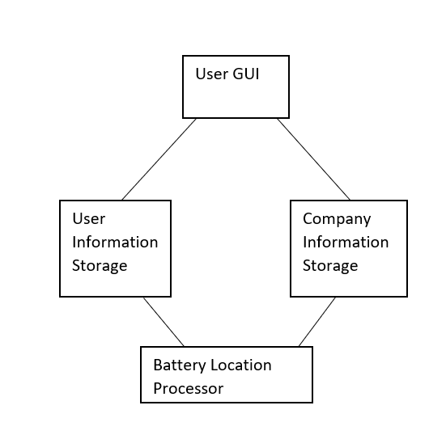

**7. Non-functional requirements (5 points) (Often called FURPS in Rational Unified Process)**

* There will need to be GPS map updates often.
* There will be security.

8. **Glossary**. (5 points)

a. You must include a complete glossary of terms. The glossary will be expanded as we go.

1. User: The person playing the game who creates an account and avatar to get coupons of their choice by gaining points through location and properly recycling used batteries.
2. Businesses: The business that has agreed to give a coupon to users each time they receive 20 points.
3. Bunny hunt game: a special feature game that the user could play when they come across a battery collection point and recycles their used batteries.
4. Bunny points: The tracking system used to help users see how to get an inventive coupon.
5. Battery collection site: A place that the user could recycle their used batteries to get points and activate the bunny hunt game.